

***Operating Lease Support System Phase-2 Project***

***for***



***Functional Specification***

***FC.AB.4.4 Monitoring Complement Document***

Revision 1.0

**PT. Berlian Sistem Informasi**

KTB Annex Bld. 4th Floor, Jl. Jend. A. Yani. Pulomas,

Tel. +62 21 4786 7575 (Hunting) Fax. +62 21 4714964 www.bsi.co.id

Document Control

|  |  |
| --- | --- |
| **Author** | Raymond |
| **File Name** |  |
| **Path** |  |
| **Number of Page** |  |

Revision History

|  |  |  |  |
| --- | --- | --- | --- |
| **Date** | **Revision** | **Description** | **Author** |
| 1/10/2015 | 0.0 | Initialization | Raymond |
| 20/11/2015 | 0.1 | Updating Contents | Raymond |
|  |  |  |  |
|  |  |  |  |
|  |  |  |  |

Distribution List

|  |  |  |
| --- | --- | --- |
| Name | Organization | Roles |
| Mr. Jin Nishimura | Dipo Star Finance, PT | DSF Project Director |
| Mr. Shinji Hosokawa | Dipo Star Finance, PT | DSF Project Advisor |
| Mr. Ahmad Fikri | Dipo Star Finance, PT | DSF Project Advisor |
| Mr. Abdul Somad | Dipo Star Finance, PT | DSF Project Manager |
| Mr. Delta Riangga | Dipo Star Finance, PT | DSF Key User |
| Mr. Mochamad Idris | Dipo Star Finance, PT | DSF Key User |
| Mrs. Herni Hembang | Dipo Star Finance, PT | DSF Key User |
| Mr. Junaidi Didy | Dipo Star Finance, PT | DSF Key User |
| Mr. Dedi Supriyadi | Dipo Star Finance, PT | DSF Key User |
| Mrs. Elke Hilviana | Dipo Star Finance, PT | DSF Key User |
| Mr. Mukhlis Ibrahim | Dipo Star Finance, PT | DSF IT Department Representative |
| Mr. Roby Wijaya | Dipo Star Finance, PT | DSF IT Department Representative |
| Mr. Daiki Kamada | Berlian Sistem Informasi, PT | BSI Project Director |
| Mr. Feri Irawan | Berlian Sistem Informasi, PT | BSI Project Advisor |
| Mr. Grand Zah Putra | Berlian Sistem Informasi, PT | BSI Project Manager |
| Mr. Raymond | Berlian Sistem Informasi, PT | BSI Business Analyst |

Document Approval

By signing this document I acknowledge I have read the document and give the Project Management Team approval to proceed.

|  |  |  |  |
| --- | --- | --- | --- |
| Role | Name | Signature | Date |
| DSF Project Director | Mr. Jin Nishimura |  |  |
| DSF Project Advisor | Mr. Ahmad Fikri |  |  |
| DSF Project Manager | Mr. Abdul Somad |  |  |
| DSF IT Department Representative | Mr. Mukhlis Ibrahim |  |  |
| BSI Project Director | Mr. Daiki Kamada |  |  |
| BSI Project Advisor | Mr. Feri Irawan |  |  |
| BSI Project Manager | Mr. Grand Zah Putra |  |  |
| BSI Business Analyst | Mr. Raymond |  |  |

Table of Contents

Document Control 2

Revision History 2

Distribution List 3

Document Approval 4

1. Introduction 6

1.1 Purpose 6

1.2 Scope 6

1.3 Definition, Acronyms, and Abbreviations 6

1.4 References 6

2. Configuration 6

3. Detail Specification: FC.AB.4.4 Monitoring Complement Document 7

3.1. Purpose 7

3.2. Screen of Configuration Access 7

3.3. Screen Functionality 7

3.4. Operation Flow 7

3.5. Screen Design 8

3.6. Component Screen Functionality 10

3.7. Operation Description 12

3.8. Data Structure 13

3.9. Screen Item List 17

1. Introduction
   1. Purpose

Functional Specification is a document to describe the detail of functions system which includes screen design, report, and logic formula. This document will be used for system development.

* 1. Scope

Functional Specification Document contains screen design, screen functionality, process flow, and data structure of FC.AB.4.4 Monitoring Complement Document for Phase-2.

Here are the scope for FC.AB.4.4 Monitoring Complement Document:

1. **AB.4.4.1 View Complement Document List**

To view document list from customer that needed for SKD Approval Process and Agreement Approval Process including status of completion.

Output from this document is:

1. PF.AB.4.4 Complement Document
   1. Definition, Acronyms, and Abbreviations
2. OPL = Operating Lease
3. DSF = Dipo Star Finance
4. BSI = Berlian Sistem Informasi
5. SKD = Surat Keputusan Direksi/ Board of Director’s Decree
   1. References

This functional specification document refers to **“To Be Design” AB. Marketing Process**, module:

1. AB.4 Marketing Operational Monitoring

* AB.4.4 Monitoring Complement Document

1. Configuration

* N/A

1. Detail Specification: FC.AB.4.4 Monitoring Complement Document
   1. Purpose

The Monitoring Complement Document screen is used by PIC Marketing Administration to view and update Complement Document from customers. This screen functions consist of view document compement list and update document complement status. Monitoring will be based on Agreement that has been created.

* 1. Screen of Configuration Access

Here are the access right for users:

|  |  |  |  |  |
| --- | --- | --- | --- | --- |
| ***User*** | ***Create*** | ***Read*** | ***Update*** | **Authorization** |
| PIC Markerting Administration | - | V | V | - |
| Marketing Officer | - | V | - | - |
| Head of Branch | - | V | - | - |
| Head of Department | - | V | - | - |
| Regional Manager | - | V | - | - |
| Advisor | - | V | - | - |
| Director | - | V | - | - |
| President Director | - | V | - | - |
| Shareholder’s Meeting | - | V | - | - |

**Legend:**

V = Have the access

* 1. Screen Functionality

1. View lists of Complement Document
2. Input status of Complement Document
3. Update status Complement Document
4. Print Complement Document
   1. Operation Flow

Below is operation flow for Monitoring and print unit preparation process refer to **To Be Design Document Marketing Process**, **AB.2.1 Board of Director’s Decree/ Surat Keputusan Direksi (SKD)**:

|  |  |
| --- | --- |
| **PIC PC** | **Process** |
|  | Agreement  (OPLAgreement)    SKD  (Tb_MKT_SKD)    Document Complent List  (Tb_MKT_DocComplementList)  Note:  Source  Output & Input    Document Complement  (Tb_MKT_DocComplement) |

* 1. Screen Design
* *Initial Screen Monitoring Complement Document for Update and Print Complement Document*

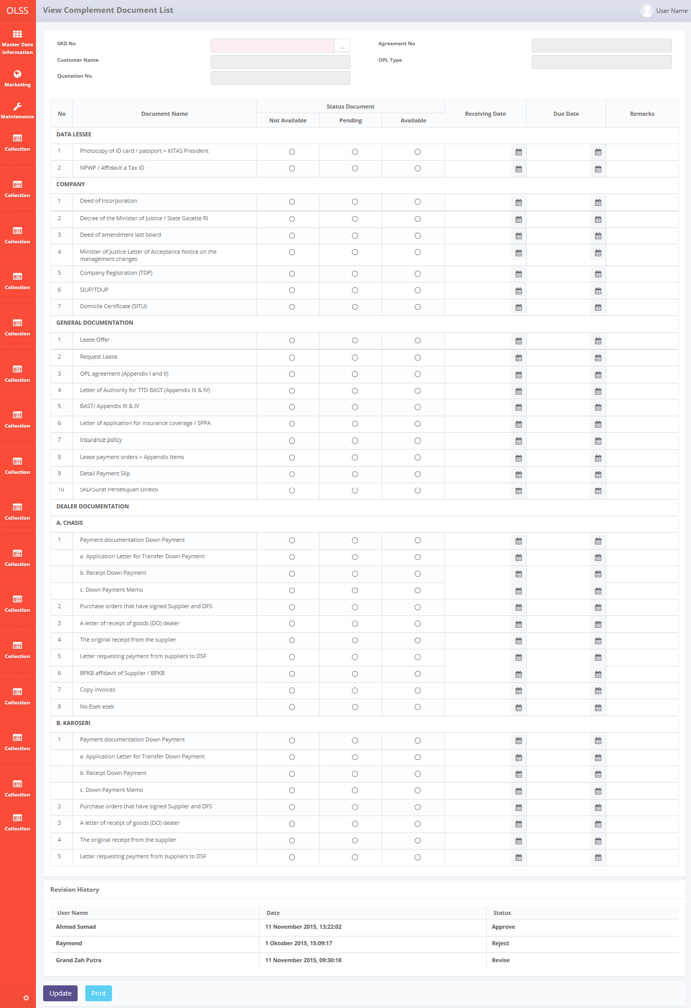

*Screen 1. Monitoring Complement Document*

* *Notification after click Update*





*Screen 2. Update Complement Document*

* 1. Component Screen Functionality
  2. **View Complement Document List**

Here are the screen functions from each component in **Screen 1. View Complement of Document List**:

|  |  |  |  |
| --- | --- | --- | --- |
| ***No*** | ***Component*** | ***Name*** | ***Function*** |
| **Header** | | | |
| 1 | Label | View Complement Document list | View Complement Document list title |
| 2 | Search Box | SKD No | To select SKD No |
| 3 | Text Box | Customer Name | Displaying Customer Name |
| 4 | Text Box | Quotation No | To show Quotation No |
| 5 | Text Box | Agreement No | Displaying Agreement No |
| 6 | Text Box | OPL Type | Displaying OPL Type |
| **Document List Header** | | | |
| 7 | Label | No | Header Table |
| 8 | Label | Document Name | Header Table |
| 9 | Label | Status Document | Header Table with 3 colspan. |
| 10 | Label | Status Document 1 Ex:”Not Available” | Header Table  The headers values retrieved from table **OptionItemValues** joined with table **OptionItems** where **OptionItems.OptionItemsName** equals “Status Document” .  This headers dynamically generated based on OptionItems. So the number of header allows for less or more than **3**. |
| 11 | Label | Status Document 2  Ex:”Pending” |
| 12 | Label | Status Document 3  Ex:”Available” |
| 13 | Label | Receiving Date | Header Table |
| 14 | Label | Due Date | Header Table |
| 15 | Label | Remarks | Header Table |
| **Document List** | | | |
| 7 | Label | No | Displaying Number |
| 8 | Label | Document Name | Displaying Document list depends on Lease Category |
| 9 | Radio button1 | Status Document1 | Displaying some radio buttons, to be in check or uncheck. |
| 10 | Radio button2 | Status Document2 |
| 11 | Radio button3 | Status Document3 |
| 12 | Date Picker | Receiving Date | Displaying Receiving Date |
| 13 | Date Picker | Due Date | Displaying Due Date |
| 14 | Text Area | Remarks | To input remarks |
| Revision History | | | |
| 15 | Label | Revision History | Revision History Sub-Title |
| 16 | Label | User Name | Displaying User Name |
| 17 | Label | Date | Displaying Date |
| 18 | Label | Status | Displaying Status |
| Footer | | | |
| 19 | Button | Update | To update the complement document list |
| 20 | Button | Print Form | To print the form |

* 1. Operation Description

|  |  |  |
| --- | --- | --- |
| **No.** | **Operation Name** | **Description** |
| 1 | Initial view of View Complement Document List | The screen for list of Complement Document:   1. Component Status;  |  |  |  |  | | --- | --- | --- | --- | | Component | Name/Caption | Status | Remark | | Label | View Complement Document list | Active |  | | Search Box | SKD No | Active | Mandatory depicted in red | | Text Box | Customer Name | Not Active | Input disabled | | Text Box | Quotation No | Not Active | Input disabled | | Text Box | Agreement No | Not Active | Input disabled | | Text Box | OPL Type | Not Active | Input disabled | | Label | No | Not Active |  | | Label | Document Name | Not Active |  | | Radio button | Status Document – Not Available | Active |  | | Radio button | Status Document – Pending | Active |  | | Radio button | Status Document –Available | Active |  | | Label | Receiving Date | Not Active |  | | Label | Due Date | Not Active |  | | Text Area | Remarks | Not Active |  | | Button | Update | Active |  | | Button | Print Form | Active |  | |
| 2 | Update Complement Document List | 1. Select the SKD Number from search box 2. Revision History will show the data, the data retrieved from Tb_MKT_DocComplement_History. 3. Change the Status Document for each document item   Constraint:  If the row no radio button selected   * If the radio button “**Not Available**” checked, the remarks will be enable. Receiving date and due date will be set disable. * If the radio button “**Pending**” checked, the due date and Remarks will be enable. Receiving date will be set disable. * If the radio button “**Available**” checked, the receive date will be enable. Remarks and due date will be set disable.   If there is selected radio button in the row   * User can only change the status with “Pending” condition to another status. * If the radio button “**Not Available**” checked, the remarks will be enable. Receiving date and due date will be set disable. * If the radio button “**Available**” checked, the receive date will be enable. Remarks and due date will be set disable.  1. Click Update button to update the document complement form. 2. If there is any selecting radio button except “select another row from selected radio button Pending” then appears message:   “Changing the status of the document on line [rowIndex] is not allowed.”   1. Update the following field (if needed) in the table Tb_MKT_DocComplement  * DocStatus * ReceiveDate * DueDate * Remarks * LastModifiedBy * LastModifiedDate  1. History Data will be stored in the table Tb_MKT_DocComplement_History and Tb_MKT_DocComplement_History_Dtl |
| 3 | Print Complement Document | Input:   1. Operation Name 3. Update Complement Document List point 1-5 2. Click button Print   Process:   1. Operation Name 3. Update Complement Document List point 6 & 7   Output:   1. Print out form **PF.AB.4.4 Complement Document** |
| 4 | System error message | Process:   1. Any errors outside of application validation or that which cannot be handled by application such as errors when communicating with database, bugs, overloop, etc will generate an error message “System error. Please contact your administrator”   Output:   1. A page with system error message will appear. |

* 1. Data Structure

1. Update Monitoring Complement Document

|  |  |  |  |  |  |  |
| --- | --- | --- | --- | --- | --- | --- |
| *Field Name* | *Data Type* | *Length* | *Source* | *Remarks* | *Nullable* | *Mandatory* |
| Primary Key View Complement Document | *Int* | *N/A* | Tb_MKT_DocComplement.IdTb_MKT_DocComplement | ***Primary Key*** | No | Yes |
| ID Complement Document List | *Int* | *N/A* | Tb_MKT_DocComplementList.IdTb_MKT_DocComplementList |  | No | Yes |
| ID SKD | *Int* | *N/A* | Tb_MKT_SKD.IdTb_MKT_SKD |  | No | Yes |
| ID OPL Agreement | *Int* | *N/A* | Tb_OPLAgreement.IdTb_OPLAgreement |  | No | Yes |
| Doc Status | *Int* | *N/A* | Tb_MKT_DocComplement.DocStatus |  | Yes | No |
| Receive Date | *Date* | *N/A* | Tb_MKT_DocComplement.ReceiveDate | *Format “mmddyyyy”* | Yes | No |
| Due Date | Date | N/A | Tb_MKT_DocComplement.DueDate | *Format “mmddyyyy”* | Yes | No |
| Remarks | *Varchar* | *100* | Tb_MKT_DocComplement.Remarks |  | Yes | No |
| Created By | *Varchar* | *20* | Tb_MKT_DocComplement.CreatedBy |  | No | Yes |
| Created Date | *Datetime* | *N/A* | Tb_MKT_DocComplement.CreatedDate | *Format “mmddyyyy hh:mm:ss”* | No | Yes |
| Last Modified By | *Varchar* | *20* | Tb_MKT_DocComplement.LastModifiedBy |  | Yes | No |
| LastModifiedDate | *Datetime* | *N/A* | Tb_MKT_DocComplement.LastModifiedDate | *Format “mmddyyyy hh:mm:ss”* | Yes | No |

**Tb_MKT_DocComplementList**

|  |  |  |  |  |  |  |
| --- | --- | --- | --- | --- | --- | --- |
| *Field Name* | *Data Type* | *Length* | *Source* | *Remarks* | *Nullable* | *Mandatory* |
| *Primary Key View Complement Document List* | *Int* | *N/A* | Tb_MKT_DocComplementList.IdTb_MKT_DocComplementList | ***Primary Key*** | No | Yes |
| Doc Category Code | *Varchar* | *20* | Tb_MKT_DocComplementList.DocCategoryCode |  | No | Yes |
| Doc Category Description | *Varchar* | *50* | Tb_MKT_DocComplementList. DocCategoryCode |  | Yes | No |
| Doc Name Code | *Varchar* | *20* | Tb_MKT_DocComplementList.DocNameCode |  | No | Yes |
| Doc Name Description | *Varchar* | *50* | Tb_MKT_DocComplementList. DocNameDescription |  | Yes | No |
| IsDelete | *Bit* |  | Tb_MKT_DocComplementList. IsDelete |  | No | Yes |
| RemarksSys | *Varchar* | *100* | Tb_MKT_DocComplementList.RemarksSys |  | Yes | No |
| Created By | *Varchar* | *20* | Tb_MKT_DocComplementList.CreatedBy |  | No | Yes |
| Created Date | *Datetime* | *N/A* | Tb_MKT_DocComplementList.CreatedDate | *Format “mmddyyyy hh:mm:ss”* | No | Yes |
| Last Modified By | *Varchar* | *20* | Tb_MKT_DocComplementList.LastModifiedBy |  | Yes | No |
| LastModifiedDate | *Datetime* | *N/A* | Tb_MKT_DocComplementList.LastModifiedDate | *Format “mmddyyyy hh:mm:ss”* | Yes | No |

**ERD Structure**



* 1. Screen Item List

**PF.AB.4.4 Complement Document**

|  |  |  |  |  |
| --- | --- | --- | --- | --- |
| *No* | *Content* | *Description* | *Source* | *Remarks* |
| 1 | Agreement No | Agreement No | OPLAgreement.AgreementNumber | *Where Tb_MKT_DocComplement.IdTb_OPLAgreement = OPLAgreement.IdOPLAgreement* |
| 2 | Customer Name | Customer Name | OPLAgreement.CustomerCode | *Where Tb_MKT_DocComplement.IdTb_OPLAgreement = OPLAgreement.IdOPLAgreement* |
| 3 | Supplier Name | Supplier Name | Supplier.IdSupplier | *Where Tb_MKT_DocComplement.IdTb_MKT_SKD = idTb_MKT_SKD.IdTb_MKT_SKD* ***AND*** *Tb_MKT_SKD.IdSupplier = Supplier.IdSupplier* |
| 4 | Unit | Unit | Tb_MKT_SKD_Dtl.Qty | *Where Tb_MKT_DocComplement.IdTb_MKT_SKD = idTb_MKT_SKD.IdTb_MKT_SKD* ***AND*** *Tb_MKT_SKD.* |
| 5 | No | Doc Code | Tb_MKT_DocComplementList | *Where Tb_MKT_DocComplementList. IdTb_MKT_DocComplementList = Tb_MKT_DocComplement. IdTb_MKT_DocComplementList AND Tb_MKT_DocComplementList.* *LeaseCategory = OPl* |
| 6 | Nama Dokumen | Doc Name | Tb_MKT_DocComplementList | *Where Tb_MKT_DocComplementList. IdTb_MKT_DocComplementList = Tb_MKT_DocComplement. IdTb_MKT_DocComplementList* |
| 7 | Y | Available | Tb_MKT_DocComplement | *(*  *(Select ItemValuesName from OptionItemValues where OptionItems.OptionItemName=”Complement Document Status”)* ***==*** *Tb_MKT_DocComplement.DocStatus)* |
| 8 | N | Not Available | Tb_MKT_DocComplement | *(*  *(Select ItemValuesName from OptionItemValues where OptionItems.OptionItemName=”Complement Document Status”)* ***==*** *Tb_MKT_DocComplement.DocStatus)* |
| 9 | R | Pending | Tb_MKT_DocComplement | *(*  *(Select ItemValuesName from OptionItemValues where OptionItems.OptionItemName=”Complement Document Status”)* ***==*** *Tb_MKT_DocComplement.DocStatus)* |
| 10 | Kondisi Dokumen | Remarks | Tb_MKT_DocComplement | *Tb_MKT_DocComplement.Remarks* |
| 11 | Action / Target | Due Date | Tb_MKT_DocComplement | *Tb_MKT_DocComplement.DueDate* |
| 12 | Disetujui Oleh | Empty | - | *-* |

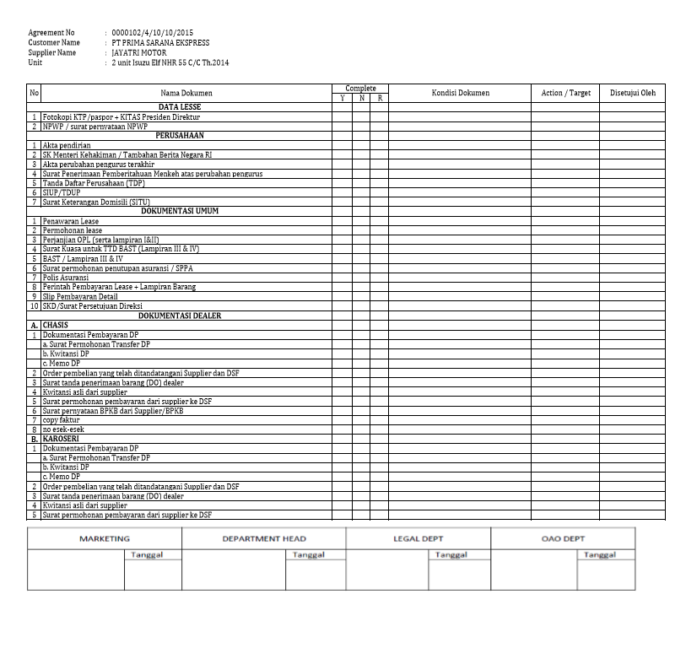

12

11

10

9

8

7

6

6

5

4

3

2

1

*Screen 2. Print Form Complement Document - Normal*

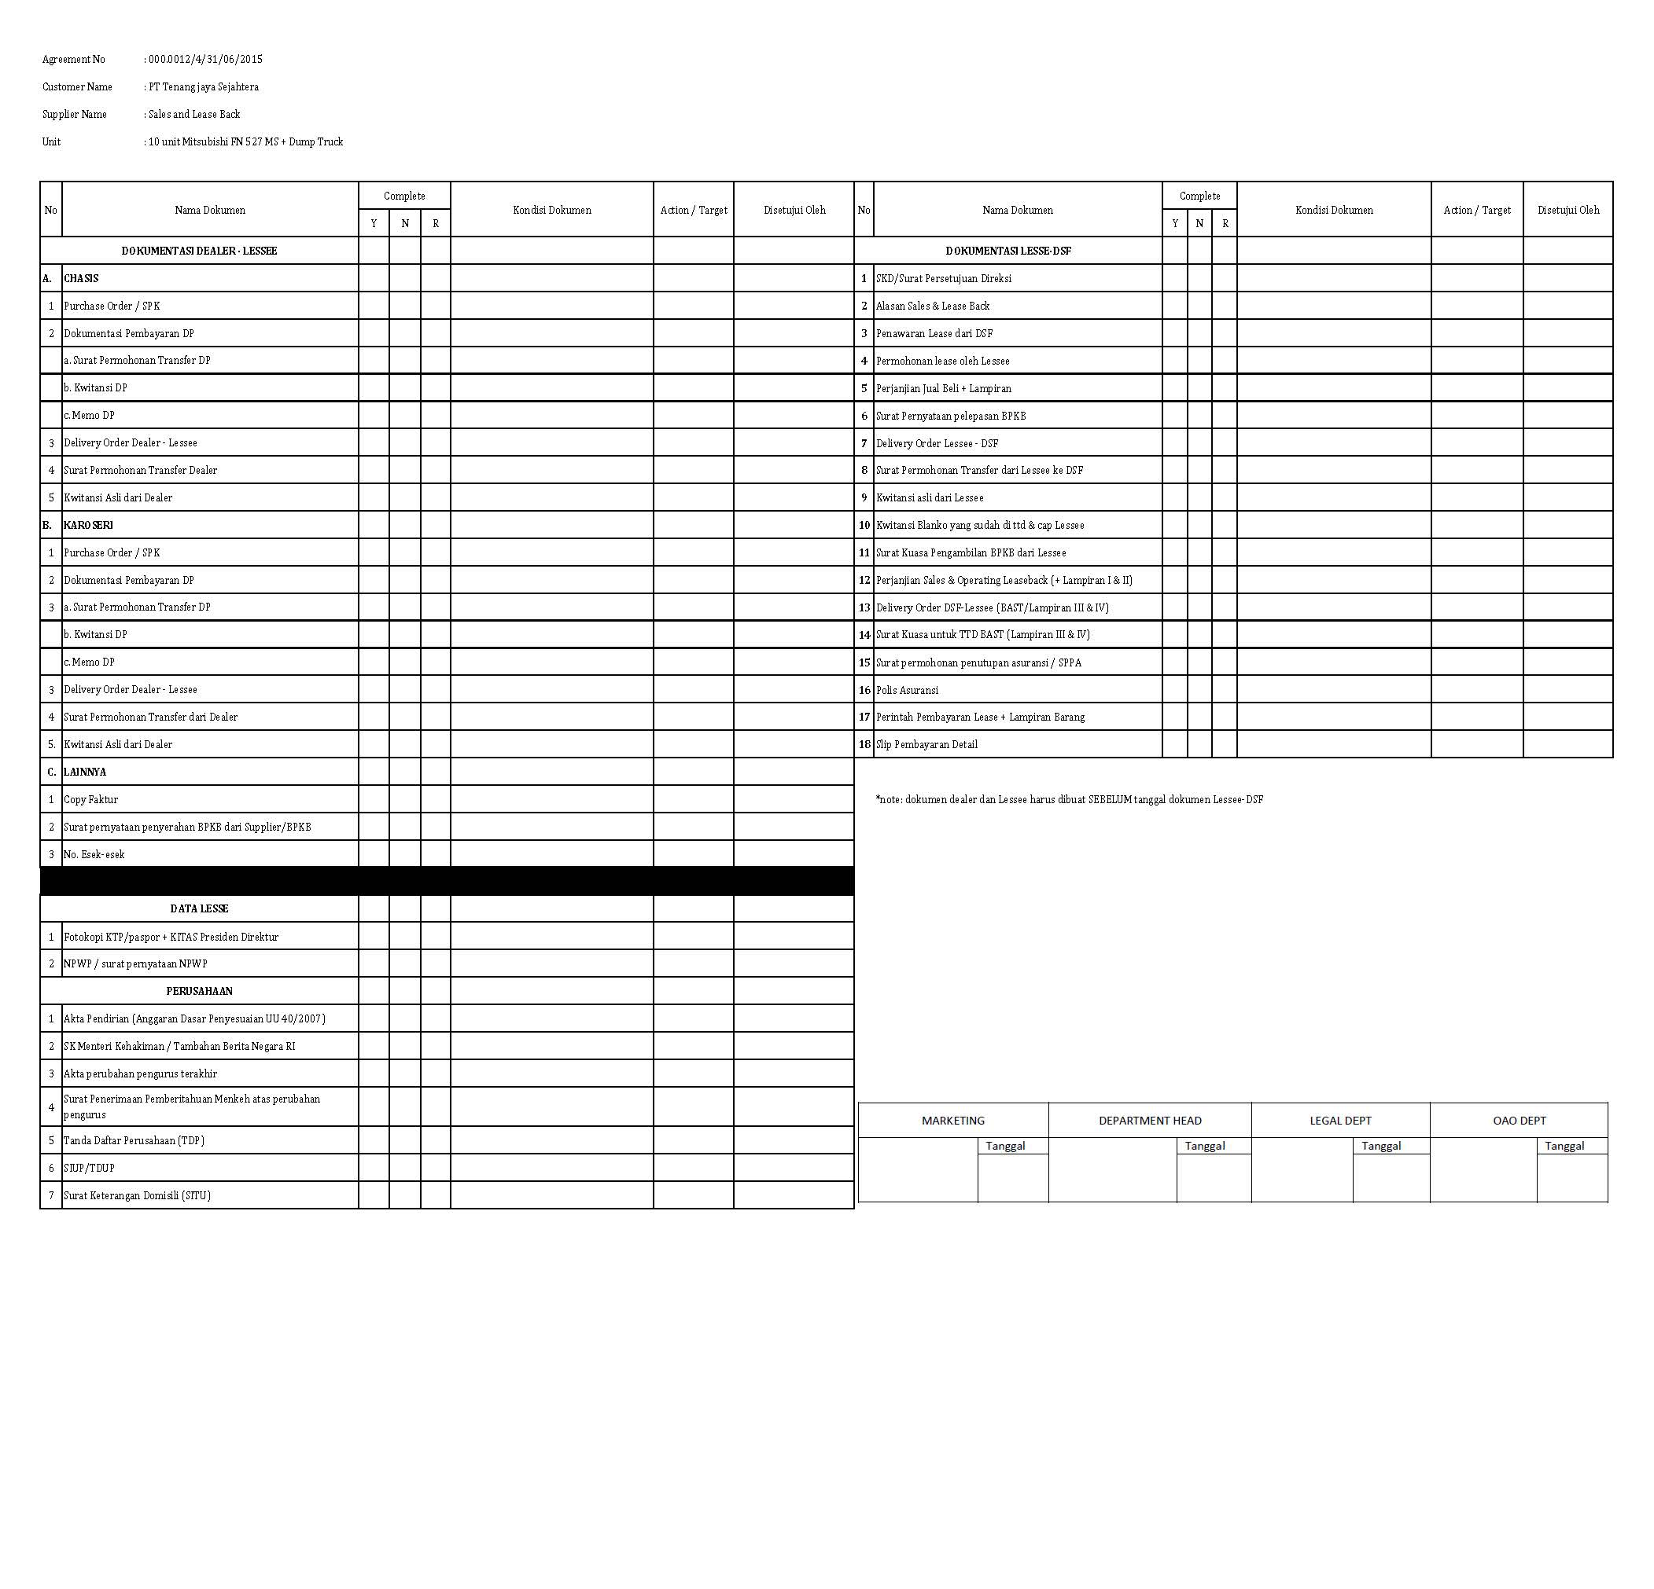

12

11

10

9

8

7

6

6

5

4

3

2

1

*Screen 3. Print Form Complement Document - Leaseback*

**APPENDIX - 1**

Configuration Access for Monitoring Complement Document functions:

|  |  |  |  |  |  |  |  |  |
| --- | --- | --- | --- | --- | --- | --- | --- | --- |
| **User** | **Branch** | **Functions** | | | | | | |
| **Edit** | | **Print Form** | | | | **Print Report** |
| **PIC Admin** | One | V | | V | | | | V |
| Area |  | |  | | | |  |
| All |  | |  | | | |  |
| Marketing Officer | One |  | |  | | | |  |
| Area |  | |  | | | |  |
| All |  | |  | | | |  |
| Head of Branch | One |  | |  | | | |  |
| Area |  | |  | | | |  |
| All |  | |  | | | |  |
| Head of Department | One |  | |  | | | |  |
| Area |  | |  | | | |  |
| All |  | |  | | | |  |
| Regional Manager | One |  | |  | | | |  |
| Area |  | |  | | | |  |
| All |  | |  | | | |  |
| Advisor | One |  | |  | | | |  |
| Area |  | |  | | | |  |
| All |  | |  | | | |  |
| Director | One |  | |  | | | |  |
| Area |  | |  | | | |  |
| All |  | |  | | | |  |
| President Director | One |  | |  | | | |  |
| Area |  | |  | | | |  |
| All |  | |  | | | |  |
| Shareholder's Meeting | One |  | |  | | | |  |
| Area |  | |  | | | |  |
| All |  | |  | | | |  |
|  |  |  |  | |  |  |  |  |
| **Legend:** |  |  |  | |  |  |  |  |
| V = Have the access |  |  |  | |  |  |  |  |